Installing Pyrevit extension

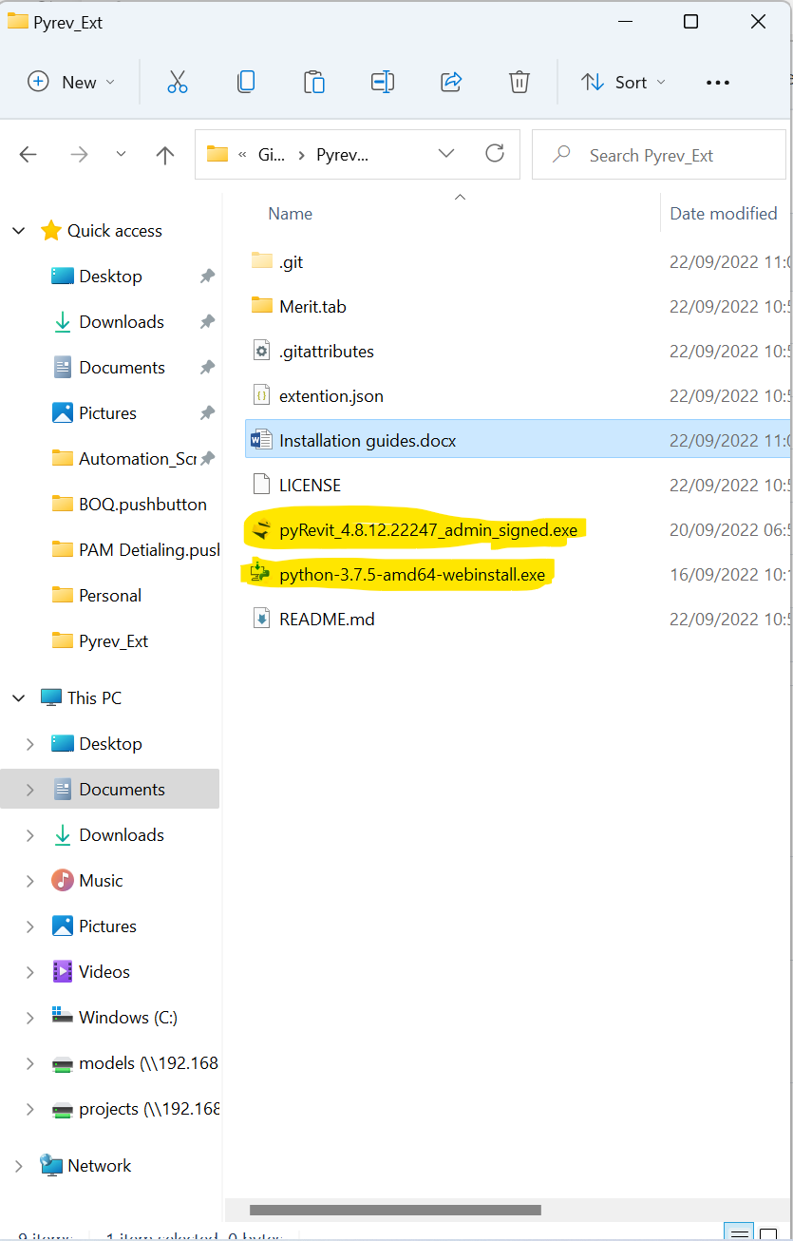Start by Installing the highlighted programs and follow the installation wizard default settings

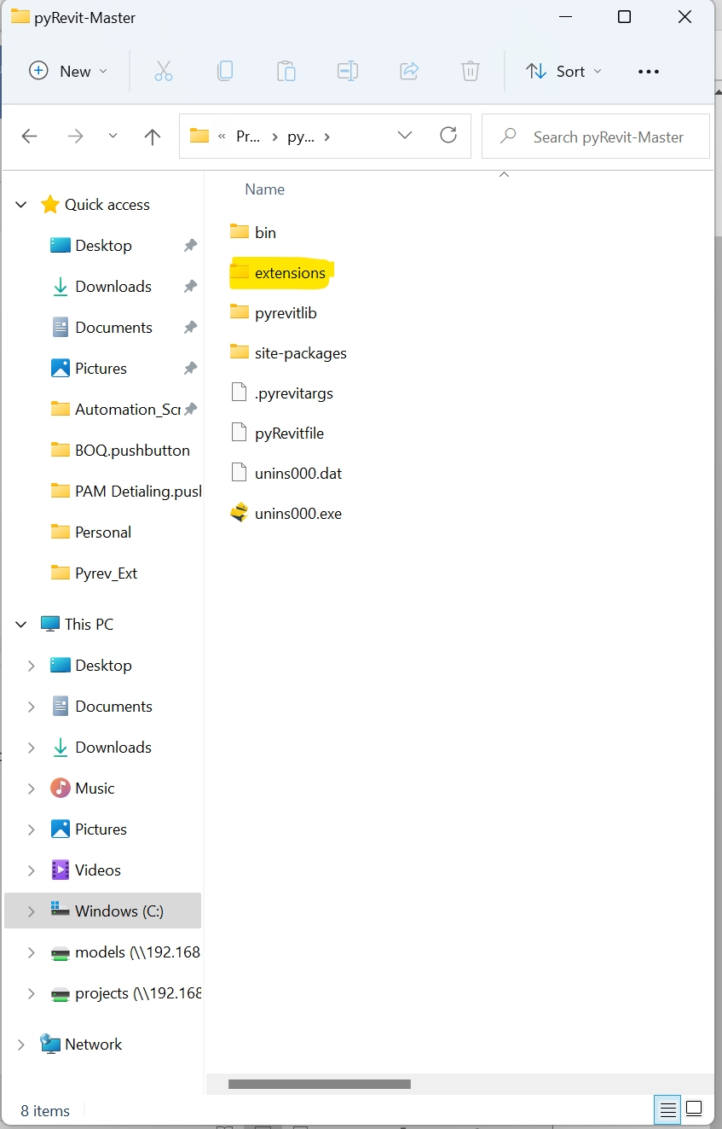Move the Merit.tab folder to the pyrevit destination directory under extension folder as shown

Pyrevit master is default installed to C:/ProgramFiles/Perevit-Master

Move inside the extension folder shown above and create a newfolder ending with .extention as shown

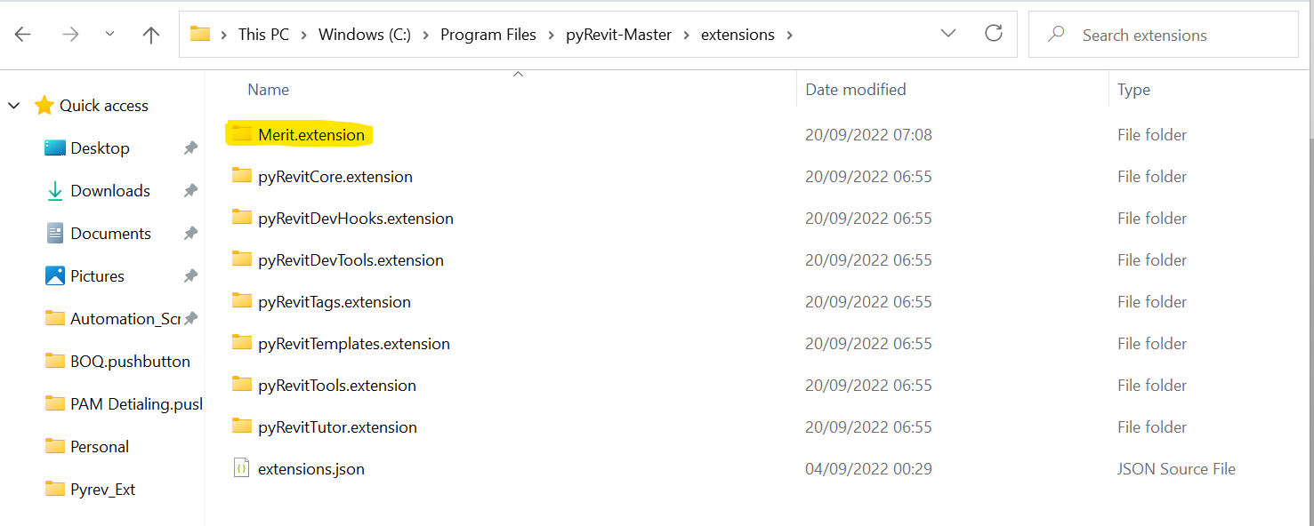

Inside that Folder place the Merit.tab

Then open Revit Navigate to the pyrevit tab



Then go to settings

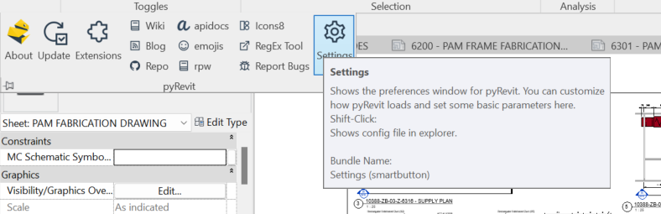dd

In settings click on Add Folder of the extension settings

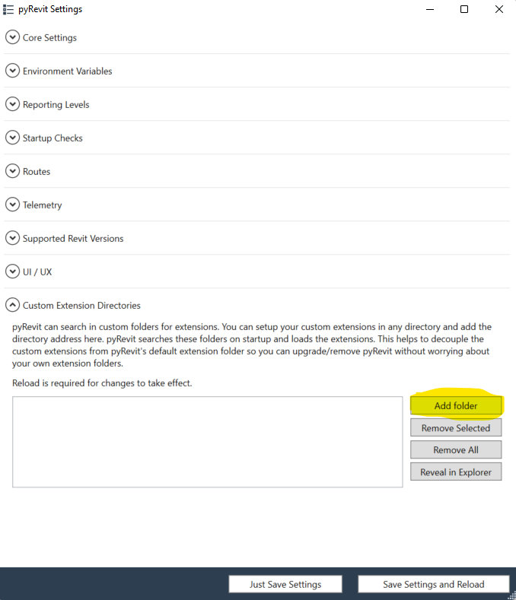

Navigate where you created the folder ending .extension and choose it